UPPERCASE DOCUMENT LIBRARY USING EVENT HANDLER

- Create satu document library sbg sample
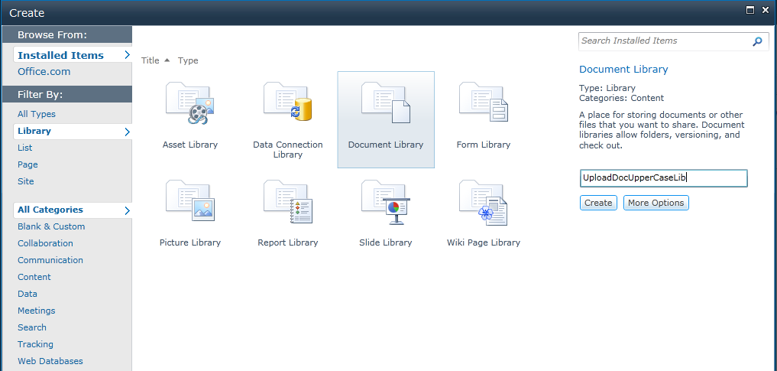

- Open visual studio 2010, create new project. Pilih Event Receiver. ( sbnrnye better pilih Empty Sharepoint Project. Tp utk contoh ni aku pilih event receiver je).

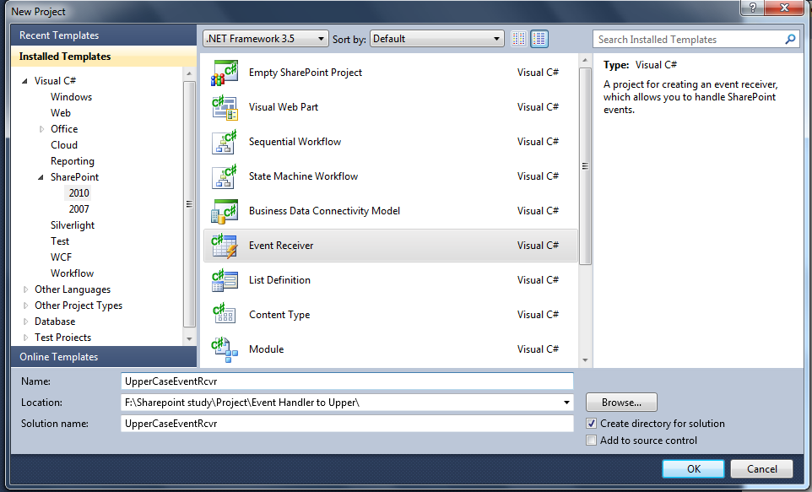

- Select document library dan tick An item was added
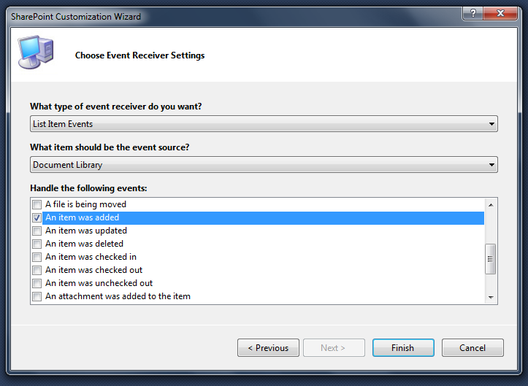

- Copy code cam gmba kt bwh ni kt eventreceiver.cs

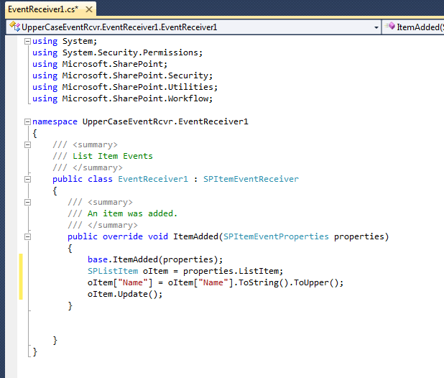

- Copy code kt bwh ni kt elements.xml
  - By default, event receiver ni trigger kt semua document library. Kalo nk wat event tuk satu list jek, gne code cam kt bwh nie. Gantikn ngn kt no 1 tu :

<Receivers ListUrl="/UploadDocUpperCaseLib">

  - Untuk yg no 2 tu plak, aku set jadik synchronous supaya event ni akan trigger sblm user take over UI.
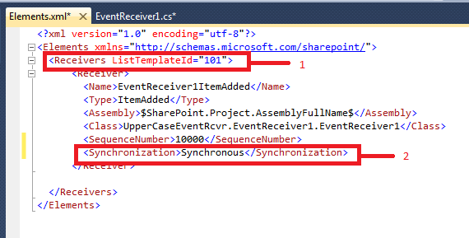
- Test upload document, filename sume jadik huruf besar.



